1) Run MySQL Workbench from your local computer. Click “+” to add a new MySQL Connection. On the connection creation screen, input below detail:

Connection Name: (Your own decided name)

Hostname: **34.129.54.95**  (The public ip of the DB instance you mark down from the GCP page)

Username: **[your given login]** (system account created for this project use)

Password: **[your given password]** (system account created for this project use)

2) Click “Test Connection” to make sure the connection is working. When it is working, click Save and then connect to the database.

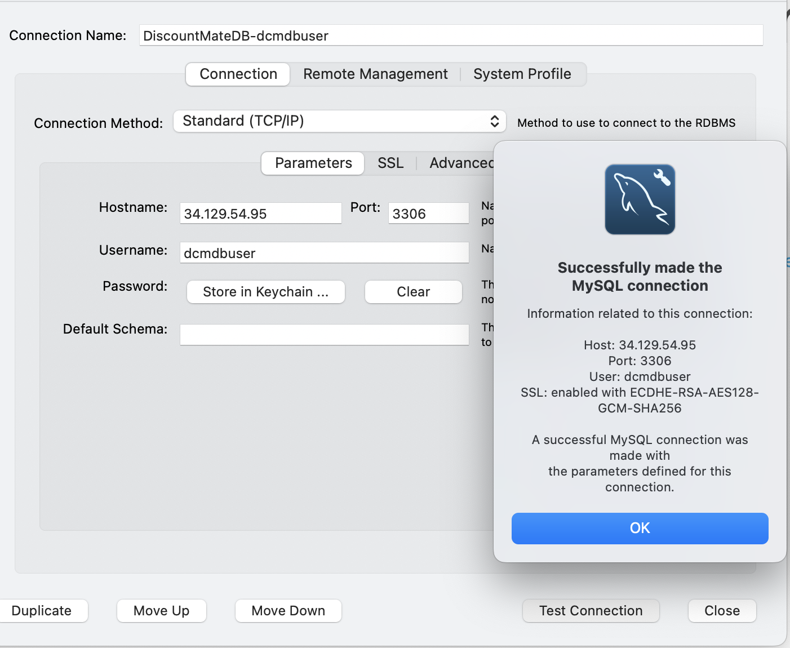

3) In the SQL editor, execute below command to access to the created DB:

**use dcmdb;**

Then now you could execute your own query for your work in this cloud database.

